**802 - HTML controls Attribute**

The **HTML controls Attribute** is used to specify that the audio and video controls must be displayed. It is a Boolean attribute and is also new in HTML5. We can use this attribute in two tags <audio> and <video> The controls attribute includes the following properties on <audio> tag:

* Play
* Pause
* Seeking
* Volume

The controls attribute includes the following properties on <video> tag:

* Play
* Pause
* Seeking
* Volume
* Fullscreen toggle (for video only)
* Captions/Subtitles (for video only, when available)
* Track (for video only, when available)

**Syntax:**

<element controls>

Below example illustrates the use of controls attribute in <audio> element.

**Example:** In this example we use the <audio> element with controls and autoplay attributes to play an audio file. It includes multiple <source> elements for different audio formats.

**Output:**

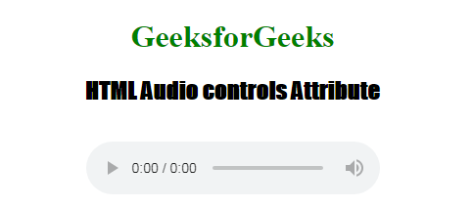

**Example:**In this example we use the <video> element with controls to embed a video player. It includes <source> elements for multiple video formats, ensuring compatibility across different browsers.



1

<!DOCTYPE html>

2

<html>

3

​

4

<head>

5

<title>HTML video controls Attribute</title>

6

</head>

7

​

8

<body>

9

<center>

10

<h1 style="color:green;">GeeksforGeeks</h1>

11

​

12

<h3>HTML video controls Attribute</h3>

13

​

14

<video width="400" height="200" controls >

15

<source src=

16

"https://media.geeksforgeeks.org/wp-content/uploads/20190616234019/Canvas.move_.mp4"

17

type="video/mp4">

18

<source src=

19

"https://media.geeksforgeeks.org/wp-content/uploads/20190616234019/Canvas.move_.ogg"

20

type="video/ogg">

21

</video>

22

</center>

23

</body>

24

​

25

</html>

**Output:**



**Supported Browsers:**